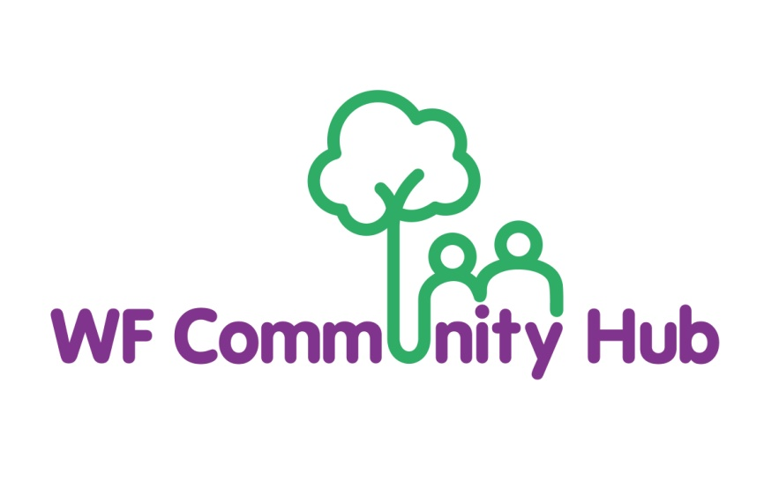

Customer Complaints Policy and Procedure

Effective date of policy: September 2025

Review date: September 2026

It is our aim to deliver a consistently high standard of customer care for all users of Waltham Forest Community Hub (the Organisation). We are committed to ensuring that service users experience a high-quality service - listening and responding to comments and suggestions for improvements.

All staff and volunteers at the Organisation are required to abide by this statement. To support them in this we shall:

- Train all front-line staff in customer care and health and safety practices and evacuation.

- Monitor staff and volunteer performance and review it annually.

Do you want to complain about the work of the Organisation?

Here’s how....

The Organisation is committed to providing a quality service. Complaints are important to help us improve our services. Comments or suggestions on our services are also very welcome either in writing, or emailing, or by telephoning or speaking to a member of staff. Complaints are handled by Head of Operations and People.

Waltham Forest Community Hub
18a Orford Road
Walthamstow
London
E17 9LN

Tel: 020 8223 0707

Email: info@wfchub.org

The Head of Operations and People shall communicate the results of the investigation to the complainant within a reasonable time, normally 21 days.

- The complainant shall have the right, if dissatisfied with the results of the inquiry, to put their case personally to the Chief Executive Officer.

- The Board of Trustees shall be informed by the Chief Executive Officer at the next meeting of the nature of any complaint and the outcome.

- Where appropriate the Organisation shall make a written apology (signed by the Chief Executive Officer or the Chair of the Board of Trustees) to the complainant.

- The Organisation has a commitment to correcting mistakes or an error made and will meet any costs, but is not liable for any losses arising.

Further Information:

The Organisation is an autonomous, independent organisation committed to resolving problems. If, after following the above procedures, you are still unhappy with the response or outcome, you may want to get further information or assistance from Citizens Advice Waltham Forest.

COMMENTS AND COMPLAINTS PROCEDURE

What does the Organisation do?

The Organisation is committed to improving the quality of the lives of local people by engaging, inspiring and empowering them to actively participate in society through a developed programme of activities, courses, conferences, seminars and training programmes.

- The Organisation aims to provide its members and individuals with the best possible service.

- However, we recognise that from time to time there may be occasions when users of services feel that the quality or level of service provided falls short of what they could reasonable expect.

- Your continued custom and goodwill is greatly valued by us and we will do our best to deal with any complaints promptly and efficiently. We would like to hear from you if you have any comments or complaints to make:

    - On the quality or nature of the service provided

- Because of being refused a service without an acceptable reason

- Because of unreasonable delays in the Organisation providing a service

- Because of decisions or actions of a member of the Organisation’s staff

- Because of a failure to provide information or giving out inaccurate information

- Because you believe you have been discriminated against because of your religion, language, gender, sexuality, marital status, age or disability, or on any other grounds

- Because you have some suggestions on how our services could be improved

Policy Review

This policy will be reviewed once a year.

