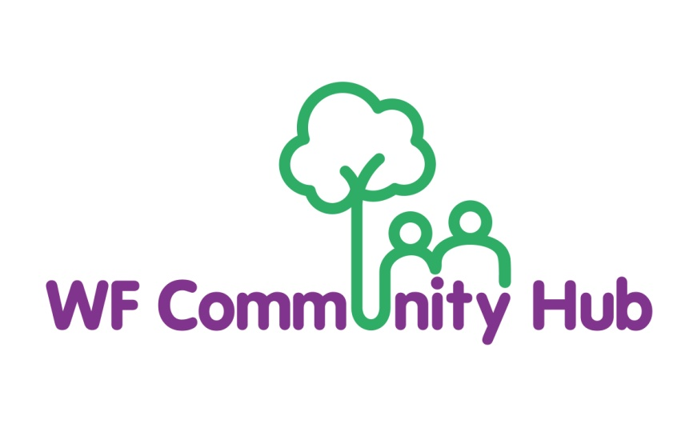

Privacy Policy

Effective date of policy: Oct 2025

Review date: Oct 2026

About this Policy - This policy explains when and why we collect personal information
about our service users, how we use it and how we keep it secure and your rights in
relation to it.

We are committed to protecting your personal information and privacy.
We may collect, use and store your personal data, as described in this Data Privacy Policy and as described when we collect data from you. We reserve the right to amend this Data Privacy Policy from time to time without prior notice.

We will always comply with the General Data Protection Regulation (GDPR) when dealing with your personal data. For the purposes of the GDPR, we will be the “controller” of all personal data we hold about you.

Your Privacy - Personal information will be treated in line with the Data Protection Act of 1998 as amended from time to time under UK law. Information provided by our service users may be shared for the purposes of audit, research or put together with other surveys, but when we do this, your confidentiality is always maintained. Personal data will not be made public in any way which identifies individuals.

Your personal data, which may be held on paper; digitally or other media, is subject to certain legal safeguards specified in the Data Protection Act and equivalent EU regulations.

This policy and any other documents referred to in it, sets out the basis on which we will process any personal data we collect from you or that is provided to us by yourself or other sources. This policy sets out rules on data protection and the legal conditions that must be satisfied when we obtain, handle, process, transfer and store personal data.

What information is being collected? We collect personal information when you use our
services such as your name, postal address, phone number, email.

How Do We Collect Personal Information? We collect personal information about you when you book our venue, register to use our services, donate to us, register for an event/class, engage with our social media, sign up to our email newsletter, or otherwise give us personal information.

How Do We Use Personal Information?
We require this information to understand your needs and provide you with a better service, and in particular for the following reasons:
• To enable you to become a member so you can join our activities.
• To process your donations or other payments, to claim Gift Aid on your donations and verify any financial transactions.
• To provide services and activities.
• To send out newsletters and other notifications.
• • To update you with important messages about your donation, an event or service.
• Where you volunteer with us, to administer the volunteering arrangement.
• To keep a record of your relationship with us.

Do We Provide Information to Other Parties?
We will never sell your data to any third party nor will we share your details with other entities for marketing purposes.

We will only share information with other organisations where we have your permission to do so in accordance with this Privacy Policy or where it is necessary for a legitimate reason connected with the services we offer, or where it is required by law or regulation.
Sometimes, we may need to share your information with a small number of trusted partners (service providers, agents and affiliated organisations) but only for the purposes outlined above. Where we use third parties, we require them to adhere to appropriate controls to protect personal information.

Cookies
‘Cookies’ are small pieces of information sent by a web server to a web browser, which enable the server to collect information from the browser. Essentially it takes the form of a small text file deposited on your computer’s hard drive. The use of cookies does not give us access to the rest of your computer or to personal information about you.

Using our Wifi at our Centre
When you use the WFC Hub Wi-Fi we may collect data about:
• your device;
• the volume of data which you use;
• the websites and applications which you access; and
• your usage by access time, frequency and location.

Your rights
You have rights under the GDPR:
• to access your personal data,
• to be provided with information about how your personal data is processed,
• to have your personal data corrected,
• to have your personal data erased in certain circumstances,
• to object to or restrict how your personal data is processed,
• to have your personal data transferred to yourself or to another organisation in certain circumstances.

Data Protection (Rights of Access)
You have the right to ask for a copy of the information we hold about you (for which we may charge a small fee) and to have any inaccuracies in your information corrected.
If you wish to exercise these rights, please contact us at 18a Orford Rd, E17 9LN info@wfchub.org

Waltham Forest Community Hub reserves the right to amend this privacy statement. The most up to date version will always be available on our website so please check from time to time, continuing to use our website you will be deemed to have accepted any changes.

This policy will be reviewed on an annual basis.

