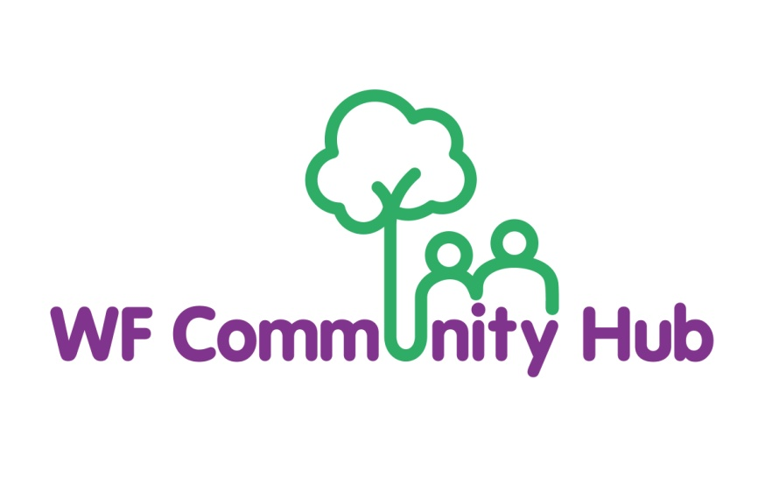

Whistleblowing Policy

Effective date of policy: November 2025

Review date: November 2026

1. Policy Statement
Waltham Forest Community Hub (the “Hub”) is committed to the highest standards of openness, integrity and accountability. We expect all employees, volunteers, trustees, contractors, and partners to maintain these standards in every aspect of their work. This policy provides a mechanism for individuals to raise genuine concerns about suspected wrongdoing, illegal acts, or malpractice within the Hub without fear of reprisal. It also aligns with the London Borough of Waltham Forest’s Whistleblowing Policy and the Public Interest Disclosure Act 1998 (PIDA).

2. Purpose
The purpose of this policy is to:
- Encourage individuals to report suspected wrongdoing as soon as possible.
- Provide clear guidance on how to raise concerns.
- Reassure individuals that they can raise genuine concerns in good faith without fear of victimisation or detriment.
- Ensure that all concerns are handled appropriately, consistently and confidentially.

3. Scope
This policy applies to all employees, trustees, volunteers, age, contractors and suppliers working with or on behalf of the Hub. It covers any concern about malpractice, risk, or wrongdoing in connection with the Hub’s activities, including those involving external partners. This policy is separate from the Hub’s grievance procedure, which deals with individual employment matters.

4. What Can Be Reported (Qualifying Disclosures)
- Concerns that should be raised under this policy include, but are not limited to:
- Criminal offences or likely offences.
- Fraud, corruption or financial irregularities.
- Failure to comply with legal or regulatory obligations.
- Miscarriages of justice.
- Endangerment of health or safety of any individual.
- Damage to the environment.
- Deliberate concealment of any of the above.

5. Protection and Confidentiality
Individuals who raise concerns in good faith will not suffer any detriment, such as dismissal, disciplinary action, or victimisation. The Hub will treat disclosures confidentially, making every effort to protect the whistle-blower’s identity, unless disclosure is required by law. Malicious or knowingly false allegations may result in disciplinary action.

6. How to Raise a Concern
- You should normally raise your concern with your Line Manager or the Chief Executive Officer (CEO). If the concern involves these individuals or you feel unable to raise it internally, you may contact:
- Chair of Trustees
- Designated Whistleblowing Officer – Head of Service Deliver

Alternatively, concerns can be raised directly with the London Borough of Waltham Forest’s Whistleblowing Contacts:

- Director of Governance and Law – whistleblowing@walthamforest.gov.uk
- Corporate Anti-Fraud Team Manager – anti-fraud@walthamforest.gov.uk
Concerns may be raised in writing, by email, or verbally. Anonymous reports will be considered, though anonymity may limit investigation.

7. How the Concern Will Be Handled
- The Hub will acknowledge receipt of your concern within five working days.
- An initial assessment will determine whether further investigation is warranted.
- If investigation proceeds, an independent manager or trustee will be appointed to conduct it.
- You will be informed of the outcome, subject to legal and confidentiality limits.
- Where appropriate, the matter may be referred to external authorities (e.g., police, regulators, auditors).

8. External Disclosure
If you believe your concern has not been properly addressed internally, or if internal disclosure is not appropriate, you may raise it with an appropriate external body, such as:
- London Borough of Waltham Forest Council Whistleblowing Hotline
- Charity Commission for England and Wales
- HM Revenue & Customs
- Care Quality Commission (if applicable)
- Protect (formerly Public Concern at Work) – independent whistleblowing advice:
Website: www.protect-advice.org.uk | Helpline: 020 3117 2520

9. Record Keeping
The Hub will maintain a confidential record of all whistleblowing reports and their outcomes. Data will be stored securely and in accordance with the UK GDPR and Data Protection Act 2018.

10. Monitoring and Review
The Board of Trustees will review this policy annually to ensure it remains compliant with best practice, legal requirements, and the London Borough of Waltham Forest’s guidance.

11. POLICY REVIEW

This policy will be reviewed once a year.

